Codingal

# Class 1:

**Not anything learned, only went through by downloading the required software and learning how to use it.**

# Class 2:

Learned about :

## Print statements:

**Print is an in-built function that takes any number of parameters and prints them out in one line of text, or it can be said to print a specified message on the screen.**

## Identifiers:

**An identifier is a name used to identify a variable, function, class, module, etc. It can be an alphabet or a combination of alphabets, underscores and digits.**

**Rules to write identifiers:**

**Identifiers can be a combination of letters in lowercase to uppercase or a digit/underscore.**

**For example, myname, Advay_12, and hello_advay**

**An identifier cannot start with a digit.**

**Keywords cannot be used as identifiers.**

**We can’t use special characters.**

## Keywords:

**A keyword is a word that has a specific meaning reserved by the programming language.**

## Variables

**A variable is user-defined. It is a quantity**

**that may change within the context of a**

**mathematical problem or program. There is**

**no specific command assigned to make a**

**variable. Instead, it creates the movement**

**you want to assign or store some**

**value to it.**

# Class 3:

**Learned about:**

## Data types

**. Data types are the types of values a variable can hold.**

**. It is a classification that specifies which type of value a variable**

**has and what operation can be performed on it.**

**1. Integer: Integers are the data types that hold only whole numbers**

**integral values, including positive and negative numbers.**

**2. Float: Float contains a fractional value (decimal numbers like**

**1.55)**

**3. Boolean: They only contain two values (True or False)**

**4. String: They have a text value or a sequence of characters. For**

**For example, coding.**

## Typecasting:

**Typecasting is a method to convert a variable data type into a specific data**

**type to perform the operation required by the users. For example**

**1. Converting a float to an integer.**

**2. Converting a string value into a float.**

**3. Converting an integer into a float**

**. What if we want to take input from users?**

**· Python allows user input.**

**. That means we can ask the user for input.**

**. For example, the input taken in the program below is of string data type.**

**print("Enter Your Name: ")**

**name = input("enter your name: ")**

**print("\nHello", name, "\nwelcome of codingal")**

## String operations:

|  |
| --- |
|  |
| **Length of string** | **The length of a string is equal to the total number of** |
|  | **characters (including spaces, special characters** |
|  | **and numbers, if any )** |
| **Indexing:** | **A particular character of a string can be accessed.** |
|  | **With the help of its index.** |
|  | **An index is used to represent the position of a** |
|  | **Character in a string.** |
|  | **The index of a word begins from 0** |
| **Slicing:** | **Obtaining a substring of a string is known as a** |
|  | **slicing** |
|  | **To slice a string, use - string_name** |
|  | **[start_index : end_index+1 : step_value]** |
|  | **By default, the step value is 1. You can reverse a** |
|  | **String by specifying the step value as -1.** |
| **Concatenation:** | **Joining two or more strings into one is** |
|  | **Called Concatenation.** |

# Class 4:

**What is an Operator?**

**. Operators are symbols that help us to perform specific mathematical and logical operations on operands.**

**. So, operators are the symbols in Python that do various**

**operations like arithmetic or logic, etc.**

**. Operands are the constants or variables on which the**

**operator operates.**

**Arithmetic operators:**

**Arithmetic operators are used for performing mathematical operations like addition, subtraction, division, multiplication etc.**

**. Operators are symbols that help us to perform specific mathematical and logical operations on operands.**

**. So, operators are the symbols in Python that do various operations like arithmetic or logic, etc.**

**. Operands are the constants or variables on which the**

**operator operates.**

**Arithmetic operators:**

**Arithmetic operators are used for performing mathematical operations like addition, subtraction, division, multiplication etc.**

**Comparison operators:**

**. Comparison operators are also called relational operators.**

**. It compares the values of two operands and returns True or False based on whether the condition is met or not.**

**Assignment operators:**

**. Assignment operators are used to perform arithmetic operations while assigning a value to a variable**

**. These operators in Python are used to store data in a**

**variable.**

**. We can also use assignment operators for logical operations or operations on integral operands and Boolean operands.  
**

# Class 5:

**Indentation:**

**. Indentation tells a python interpreter that the group of statements**

**belongs to a particular block of code.**

**. In python, indentation is used for highlighting the block of code.**

**. The leading white space character is added at the beginning of a**

**statement to indicate a code block.**

**. It is important because you will see indentation errors without proper**

**indenting of the python code, and the code will not get compiled.**

**. Indentation helps in managing and maintaining the code.**

**. We can indent the code by using the tab key or space key.**

**How do I fix indentation in python?**

**1. Check for the wrong white space or tab.**

**2. Be sure that the indentation for a specific block remains the same**

**throughout the code.**

**Conditional statements :**

**· Conditional statements are also called decision-making statements.**

**. In this, a statement expression or condition is tested, and depending on**

**the test condition, it returns true or false, then the other block of code is**

**executed.**

**IF statement**

**Else statement**

**. If Jack is thirsty. Then she drinks water.**

**. if you live in Texas, then you live in Richmond/**

**. If it's raining, then carry an umbrella. Else wear**

**the hat.**

**. If I get at least 10 rupees, I will buy Sprite.**

**Else, I will buy candy.**

# Class 6:

**If, Elif else statements:**

**. The Elif statement allows you to examine multiple statements for True and executes a block of code as soon as one of the conditions becomes true.**

**. If all the conditions are false, the body of the else will execute.**

**. And the important thing is that if statements can be written with or without anything else.**

**. But it can't be used without an else statement.**

**. And there is no strict limit to how many else if statements can be included after an if statement.**

**. You can add as many statements as you need in a program.**

# Class 7:

Learned all the above material and did activities and challenges for the rest of the class.

# Class 8:

Expression:

An expression is a representation of a value. It is different from a statement in the fact that a statement does something while a statement is a representation of value.

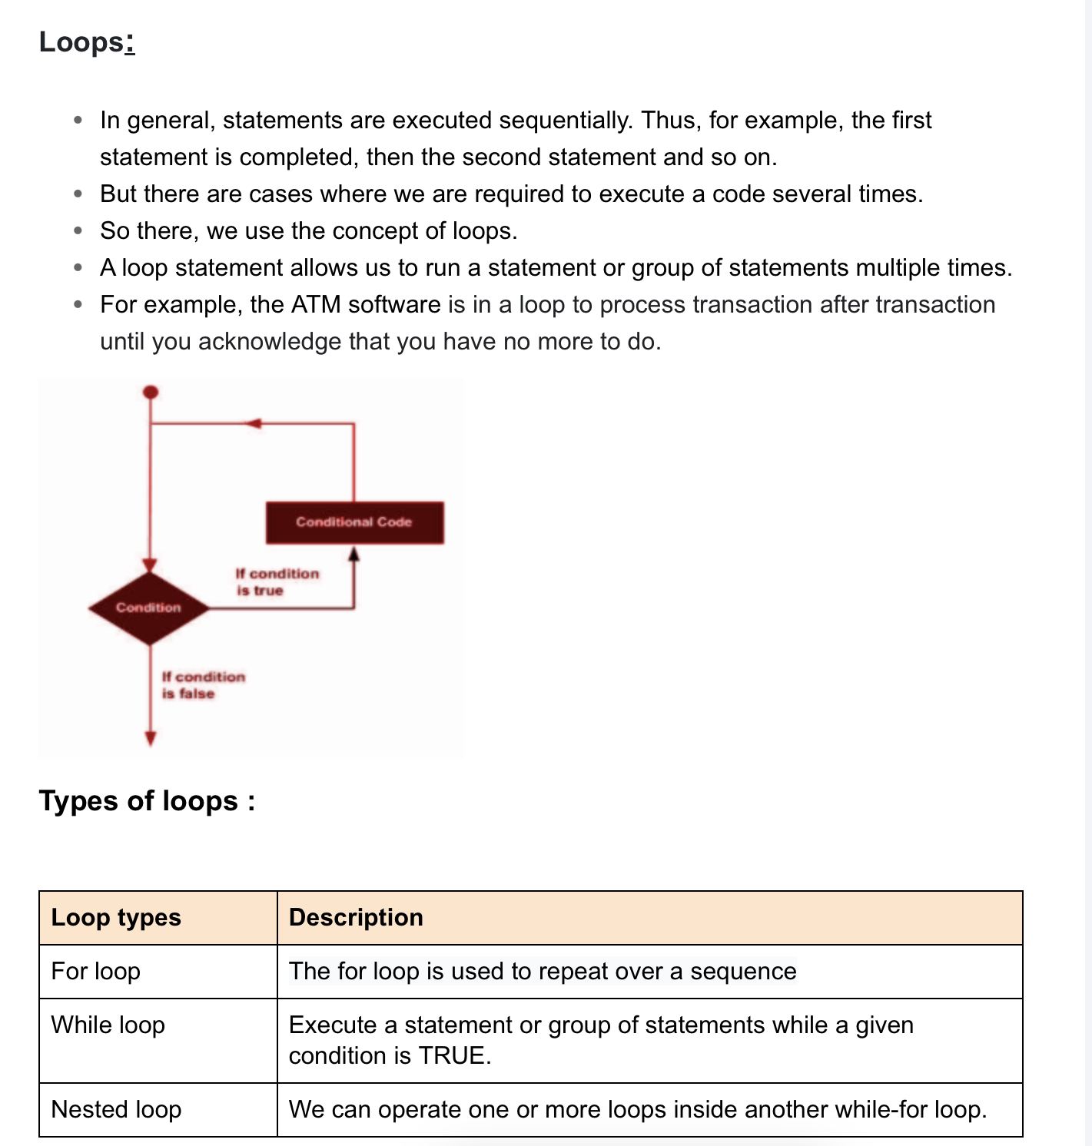Class 9:

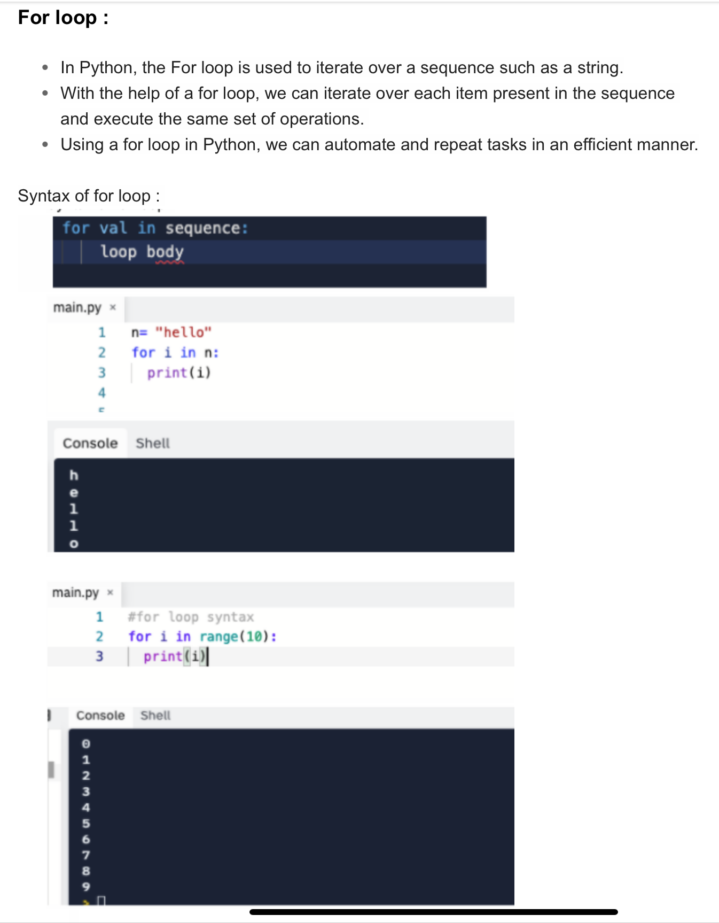

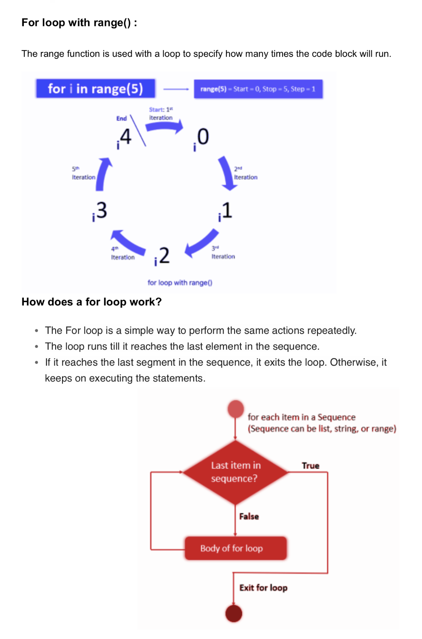

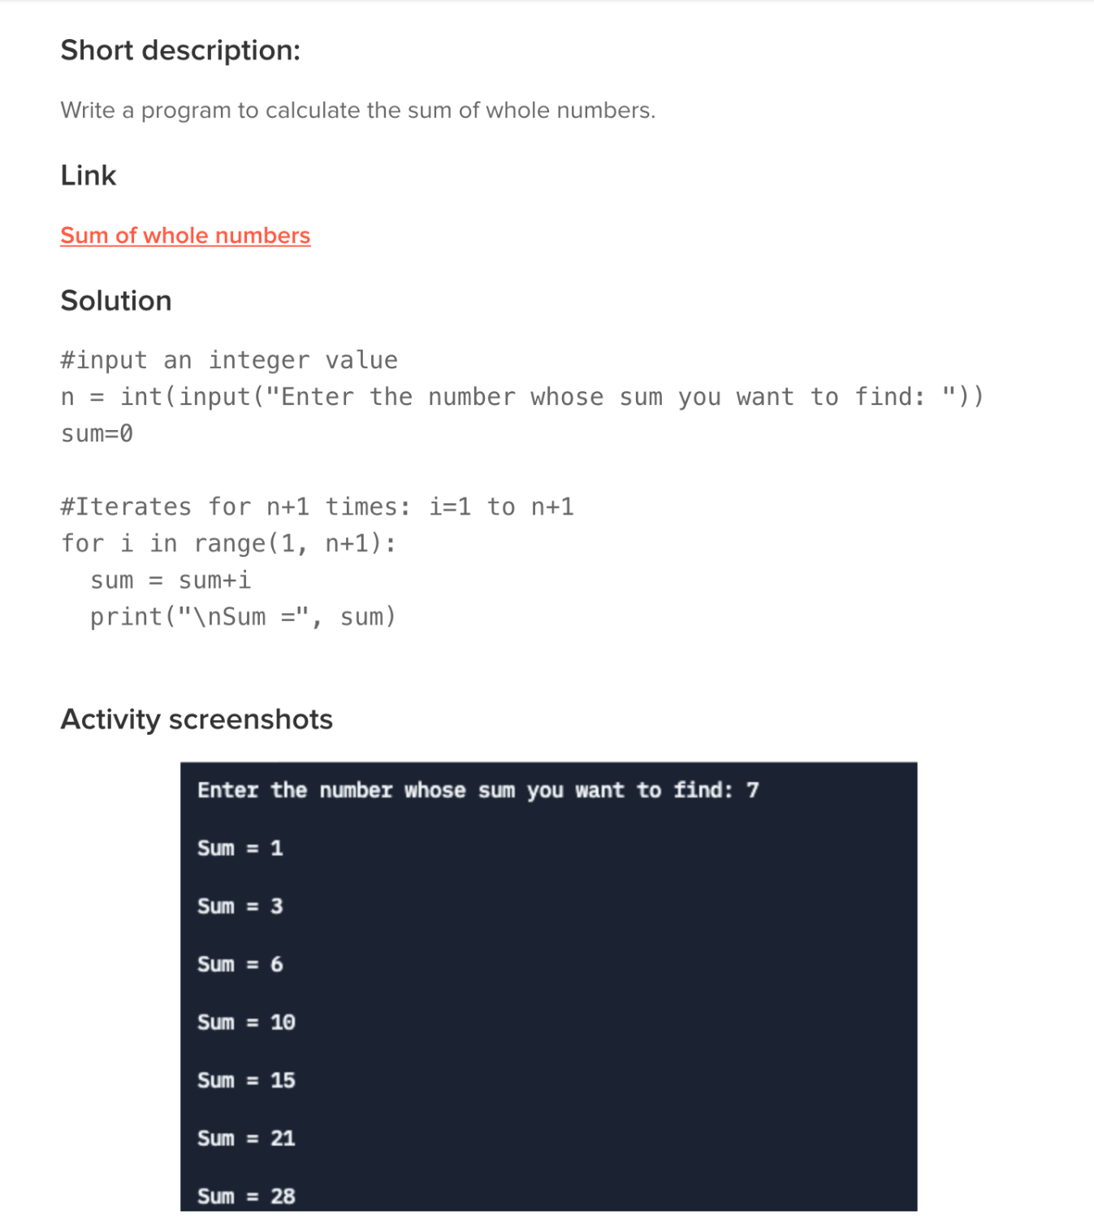**Learned the above material and did following activities for the rest of the class:**

**Class 10:**

Learned above material and did following activities for the rest of the class:

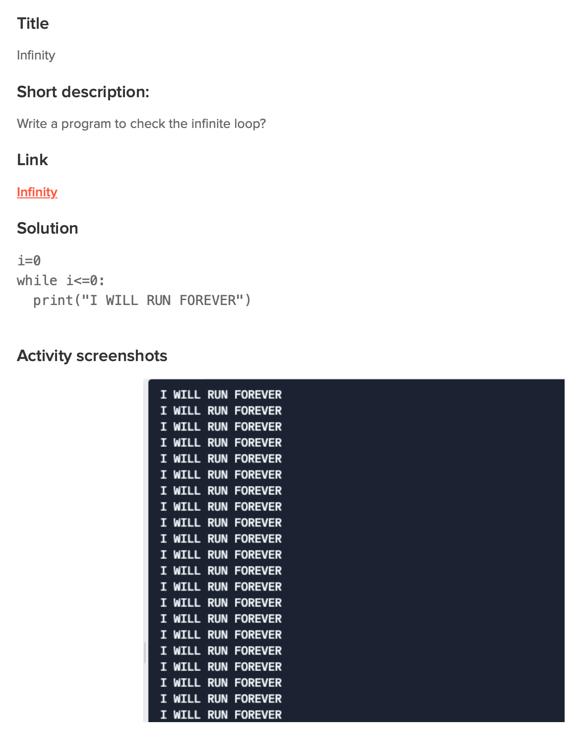

Class 11:

Learned above material and did following activities for the rest of the class:

Class 12:

Learned above material and did following activities for the rest of the class:

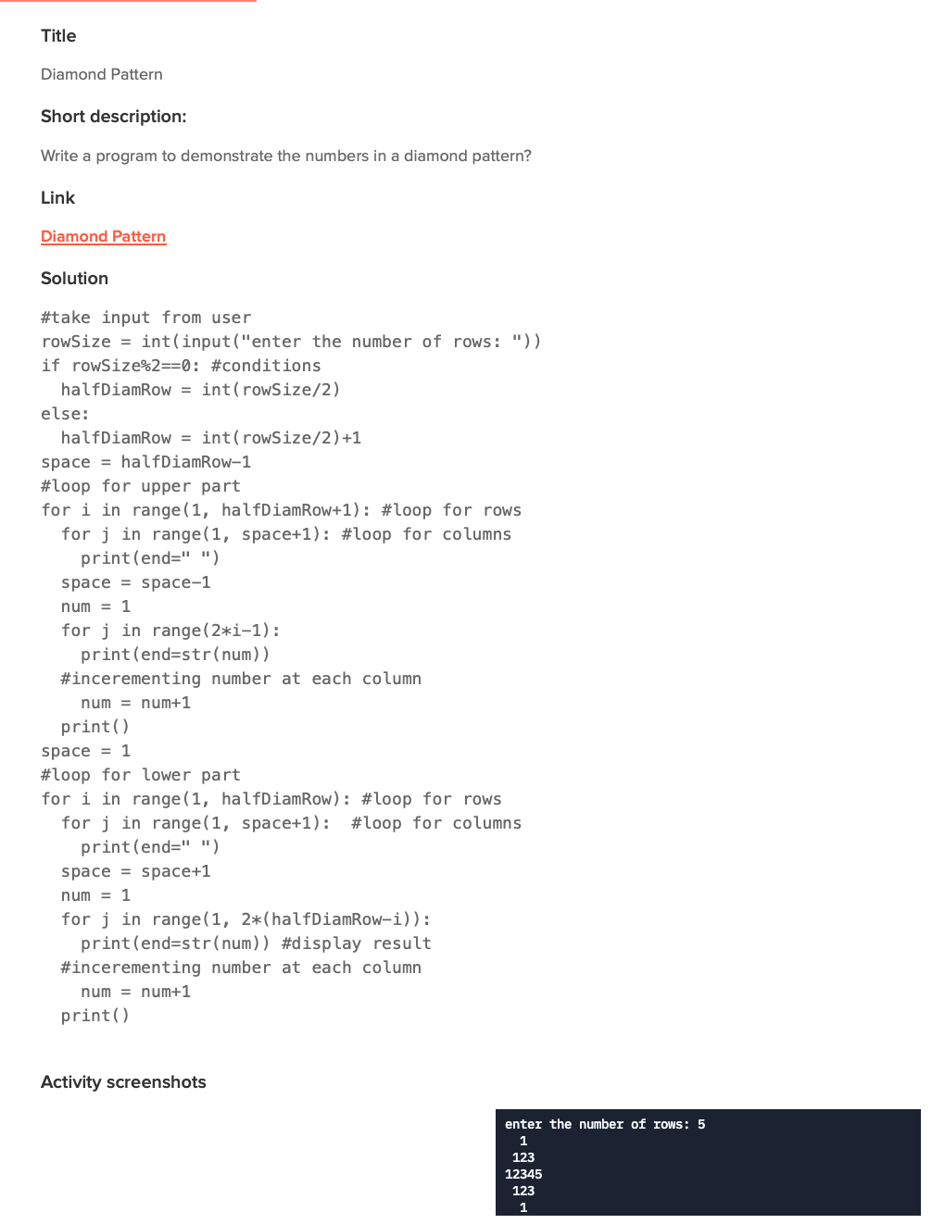

Class 13:

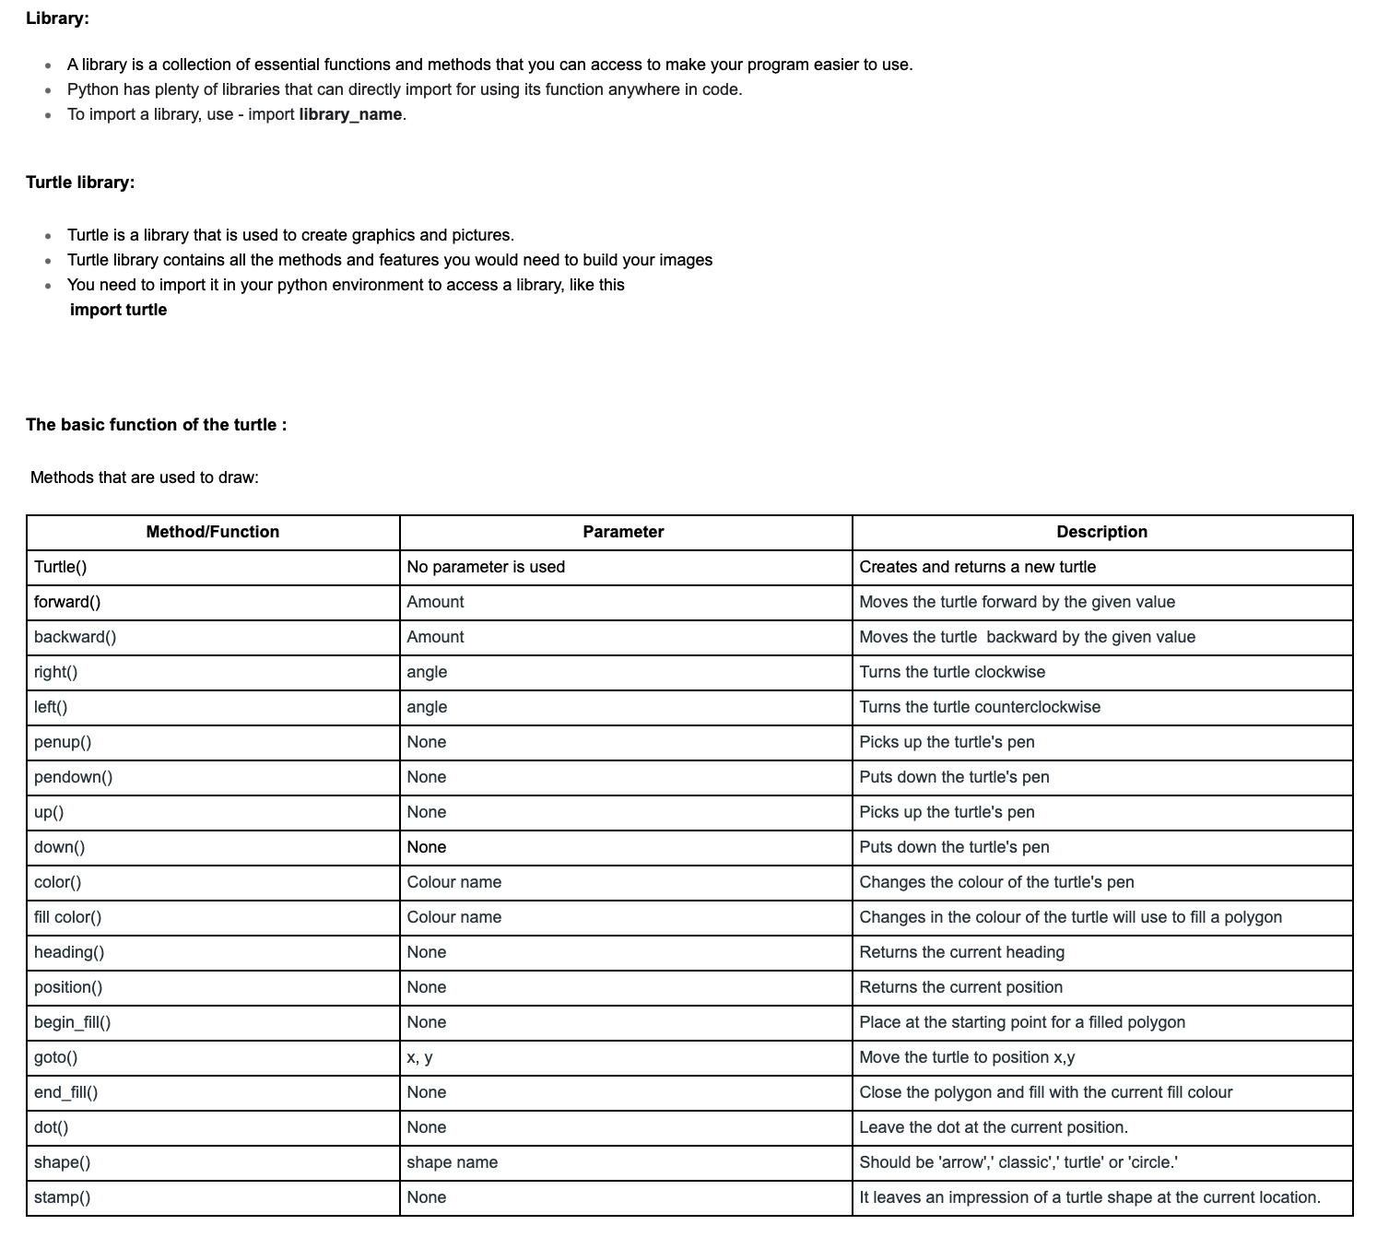

Learned above material and did following activities for the rest of the class:

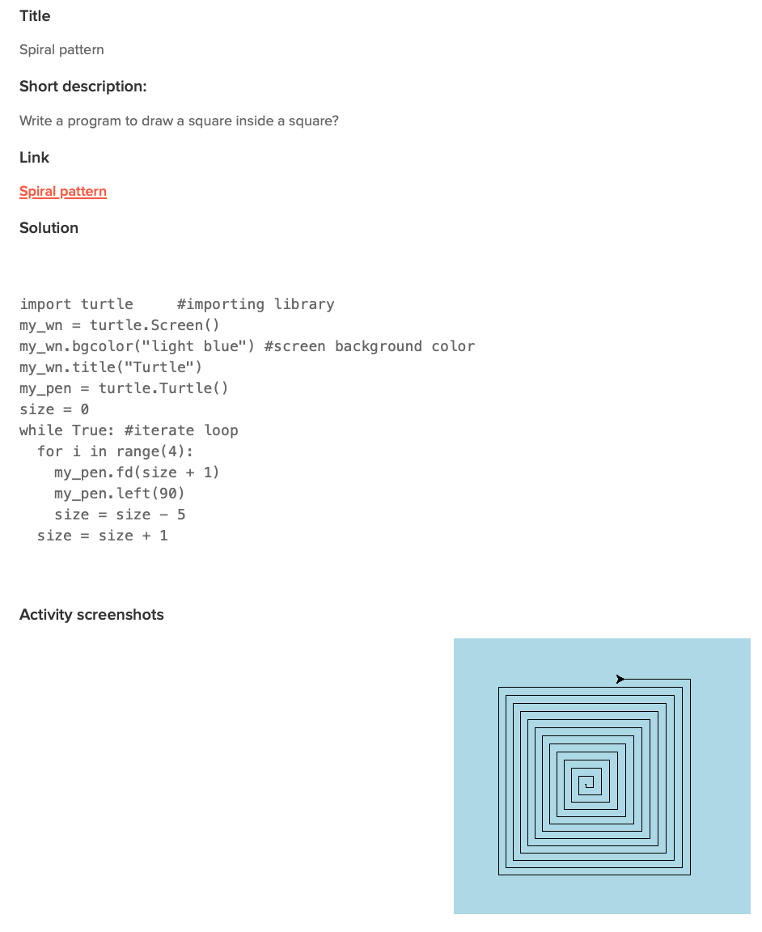

Class 14:

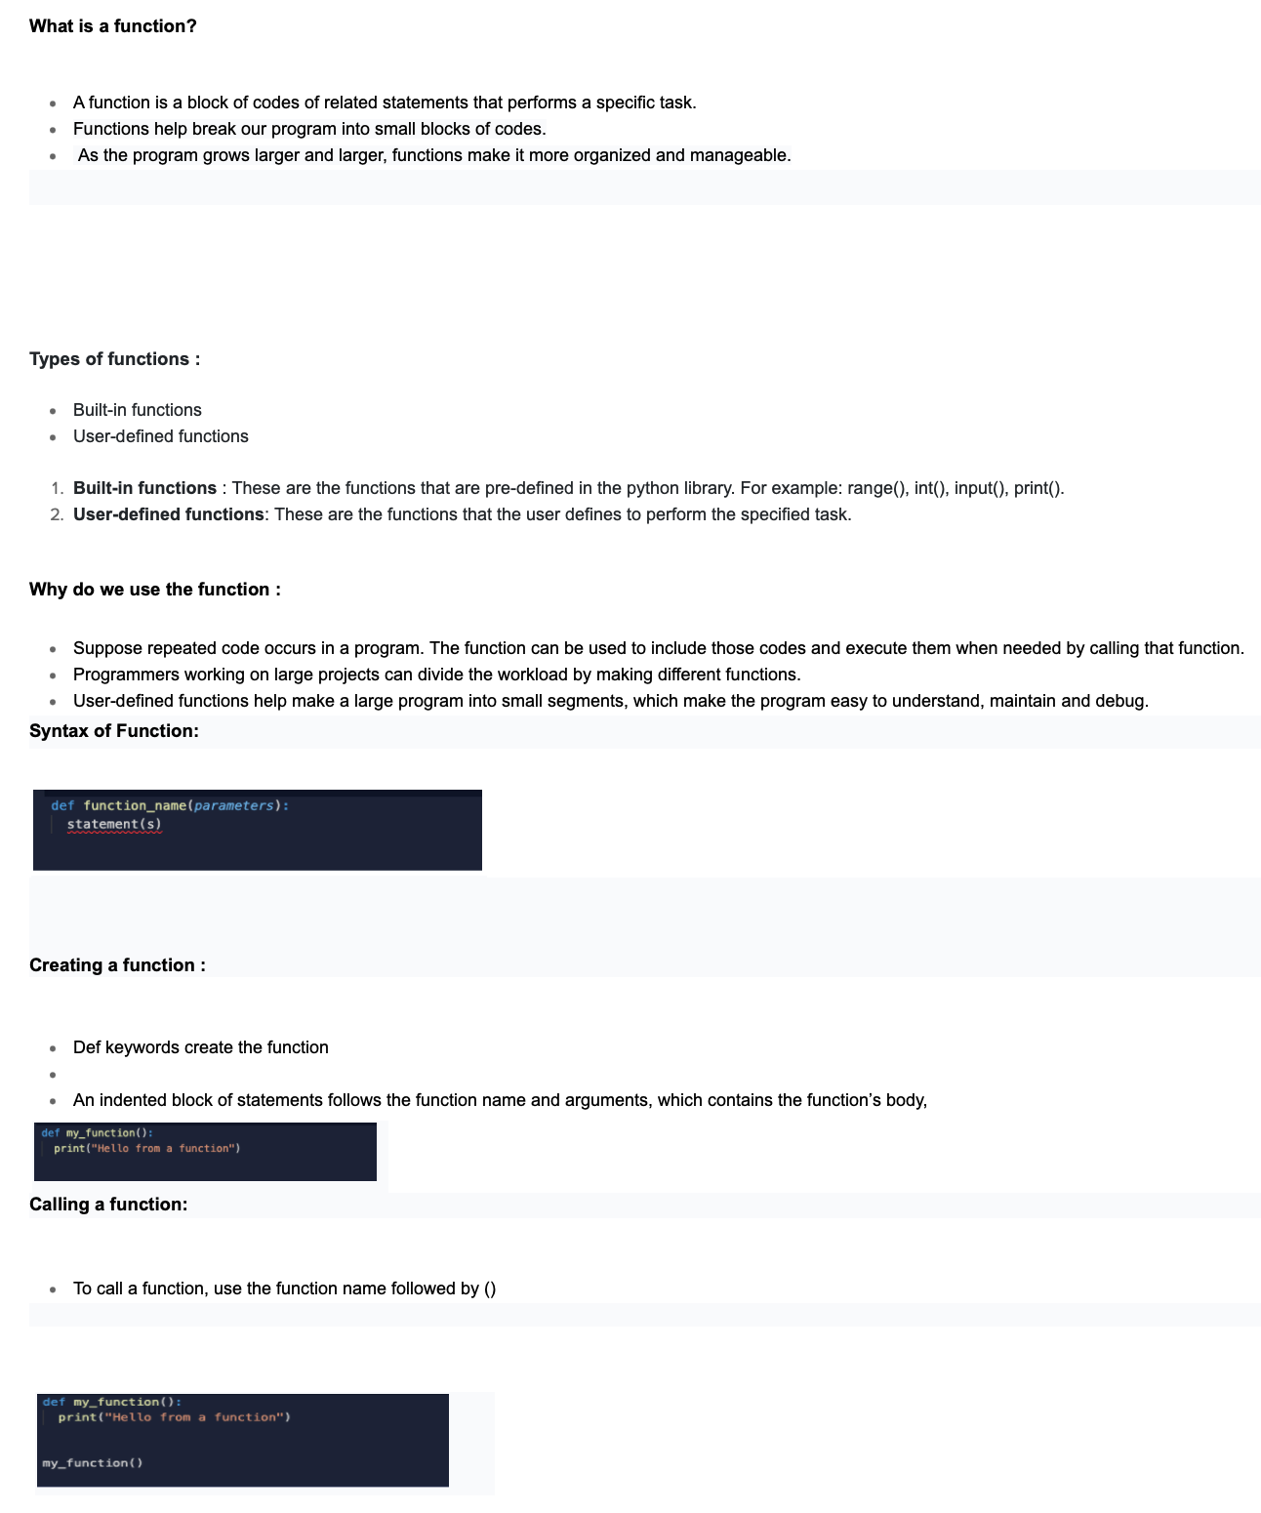

Learned above material and did following activities for the rest of the class:

Class 15:

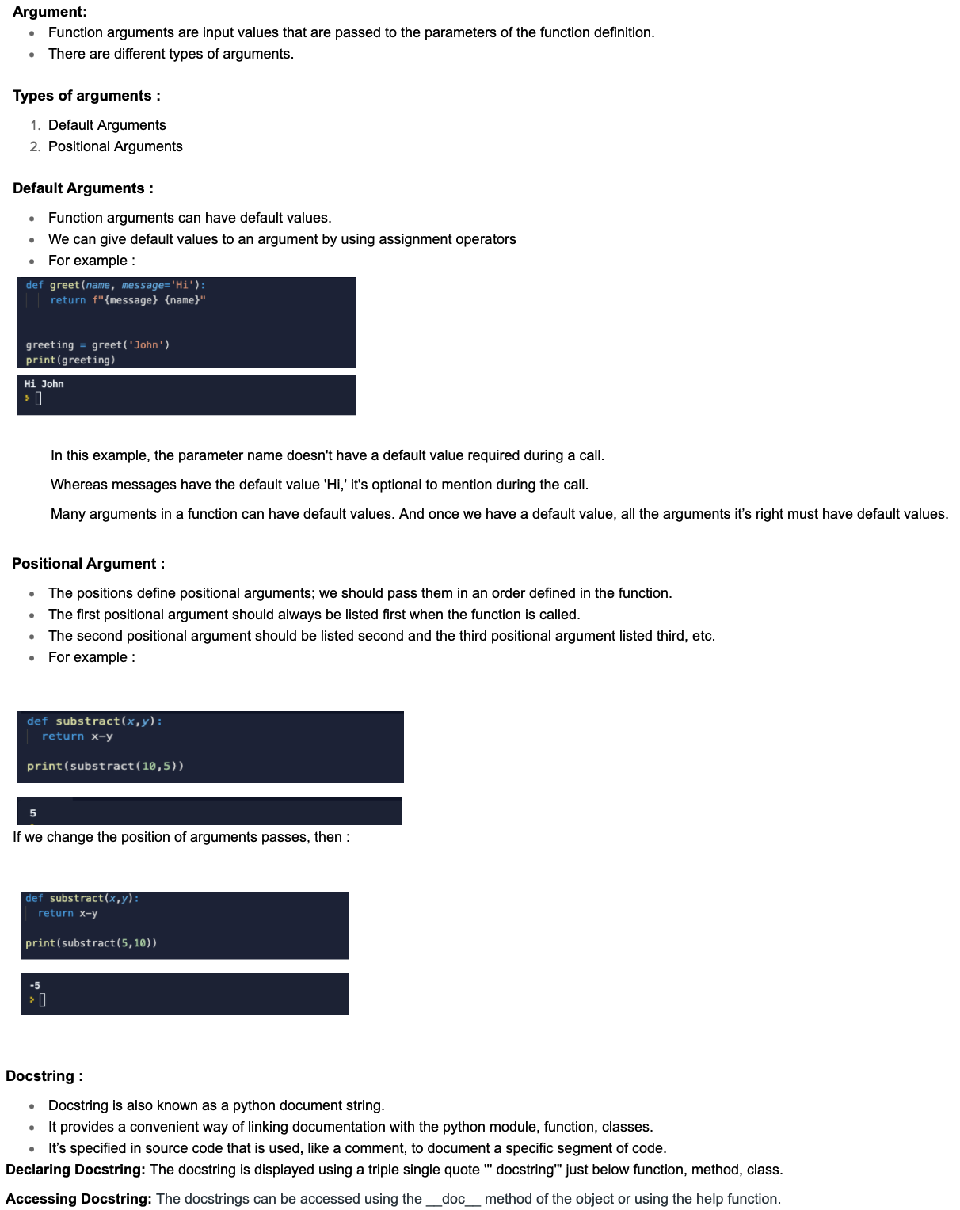

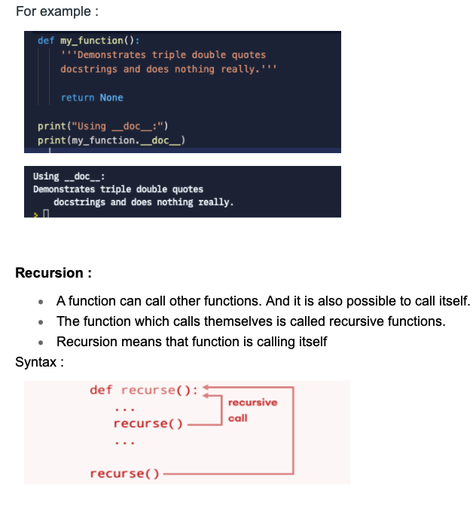

Learned above material and did following activities for the rest of the class:

Class 16:

Learned above material and did following activities for the rest of the class:

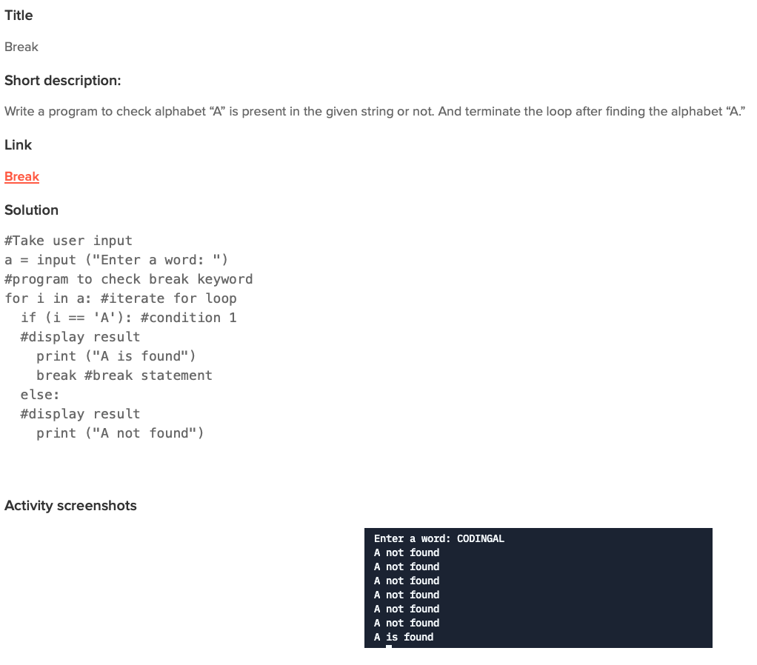

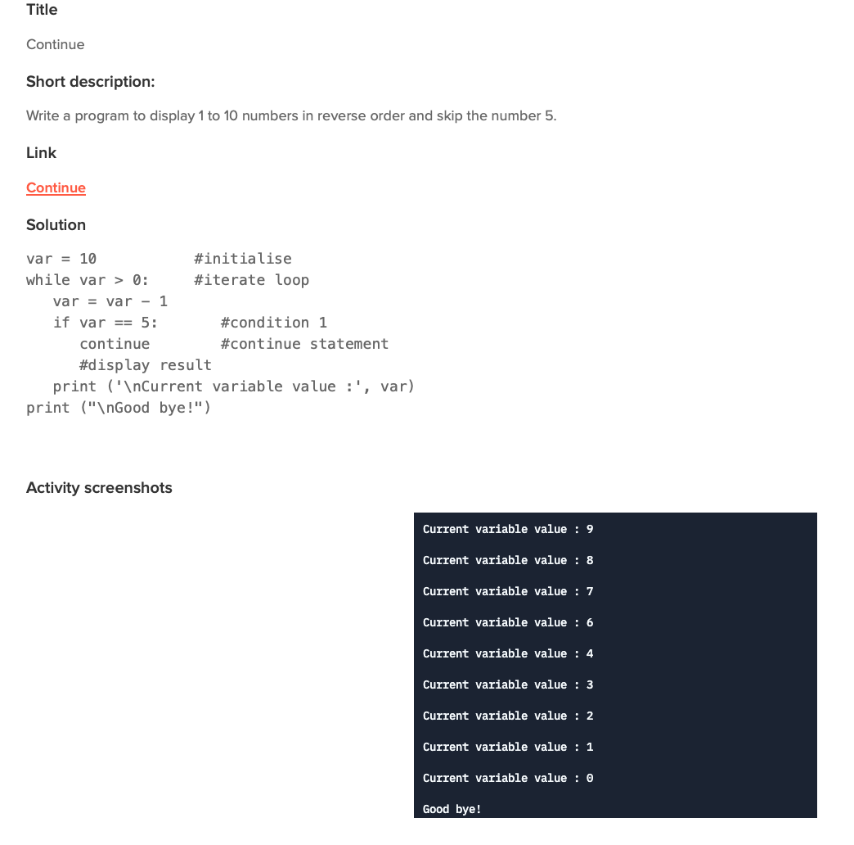

Class 17:

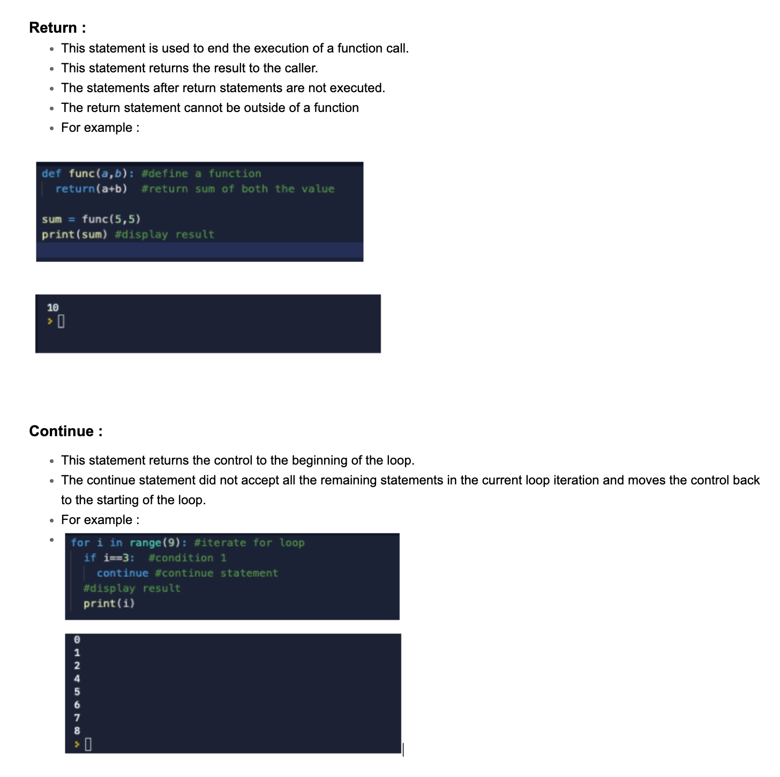

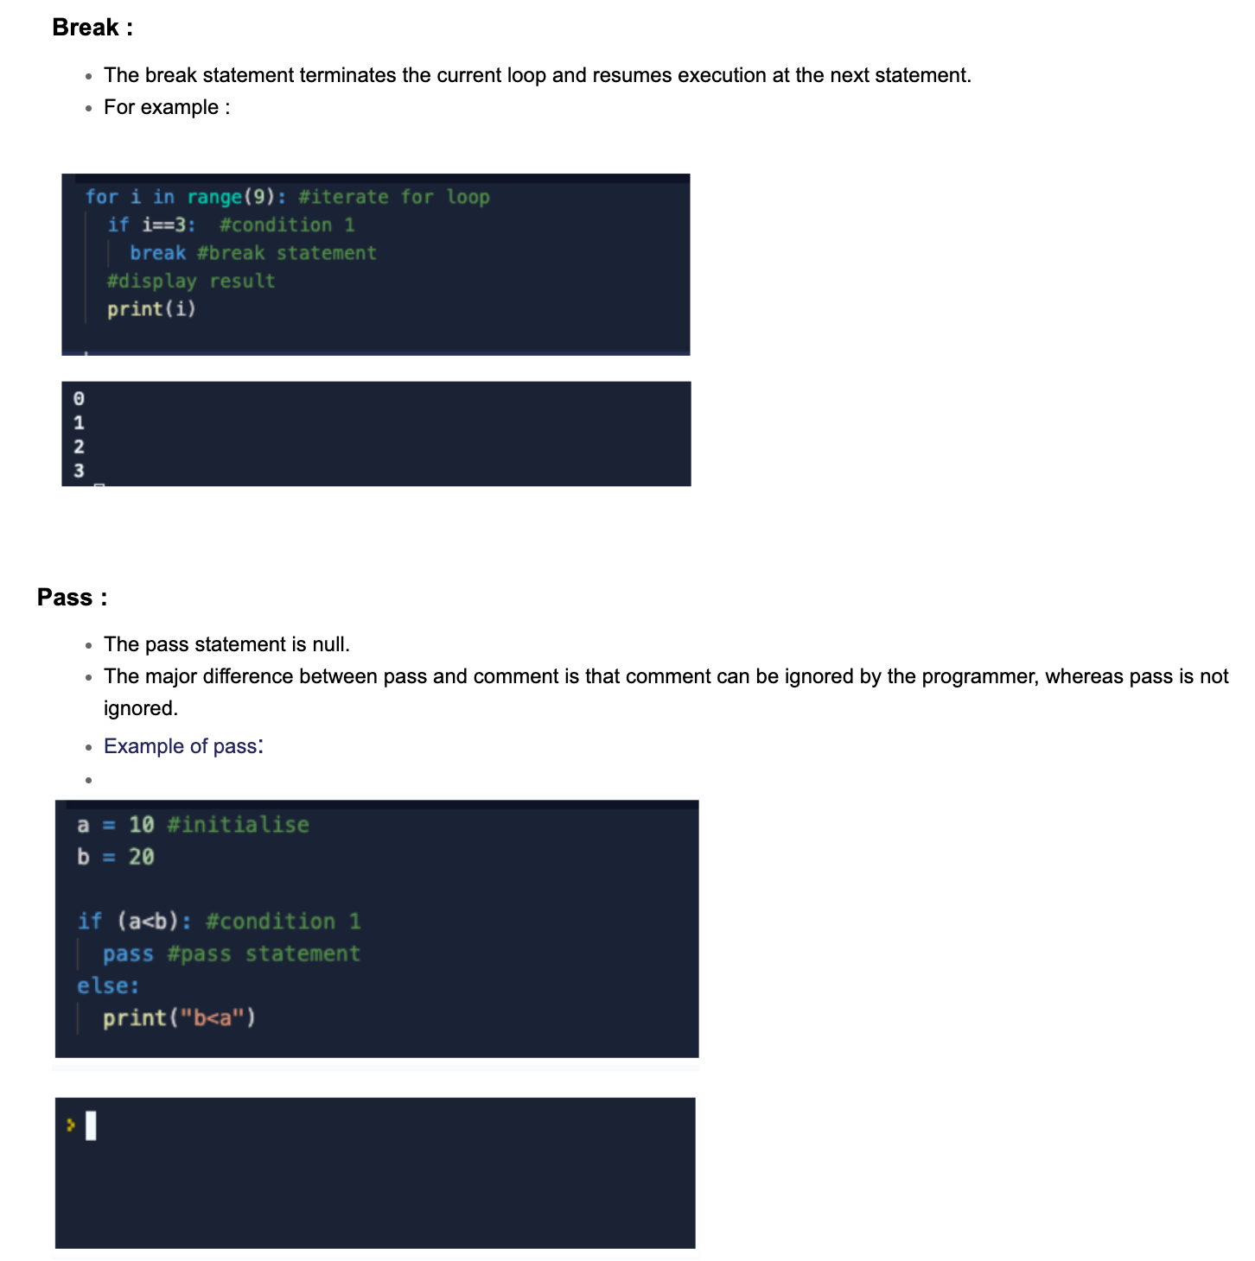

Learned above material and did following activities:

Class 18:

Learned above material and did following activities:

